**Facilities for Differently-Abled**

The college building offers facilities of ramps to ensure accessibility and comfort for all and specially for students with special needs. Ramps provide easy access to all floors. Three disabled-friendly toilets are available in the college. Human Assistance or Help Desk is given, if needed.

**Disabled Friendly Toilets**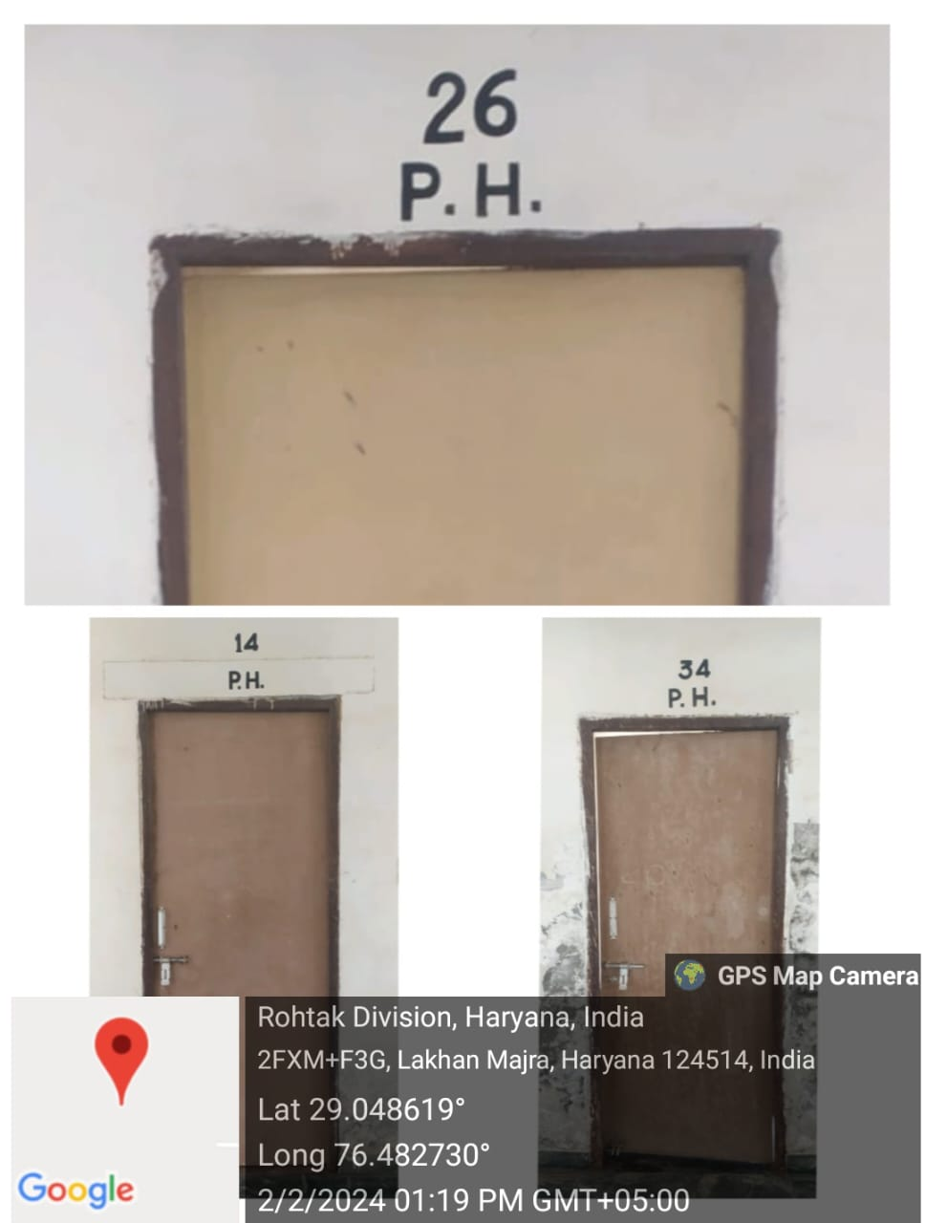

**Ramps for Easy Access to all floors**

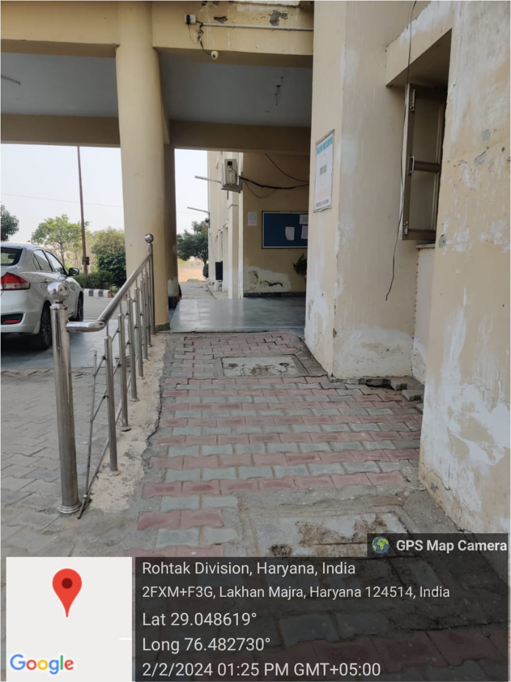 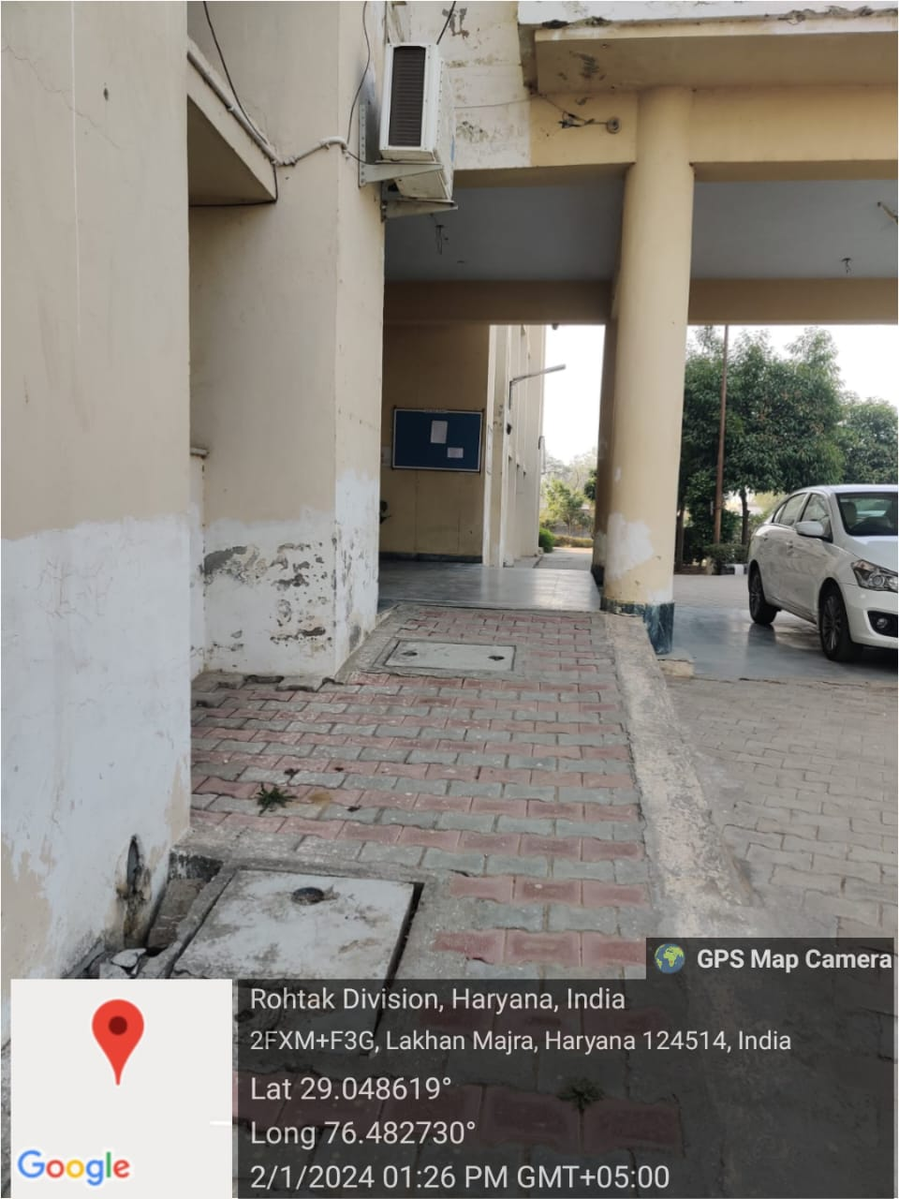 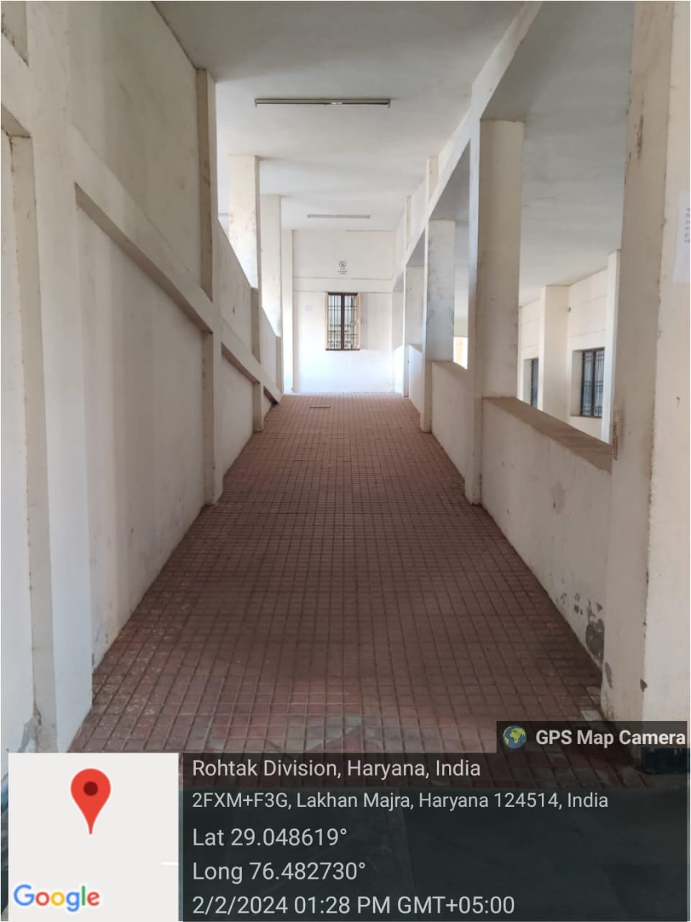

**Human Assistance/ HelpDesk**

